Three Circle Kingdom gospel
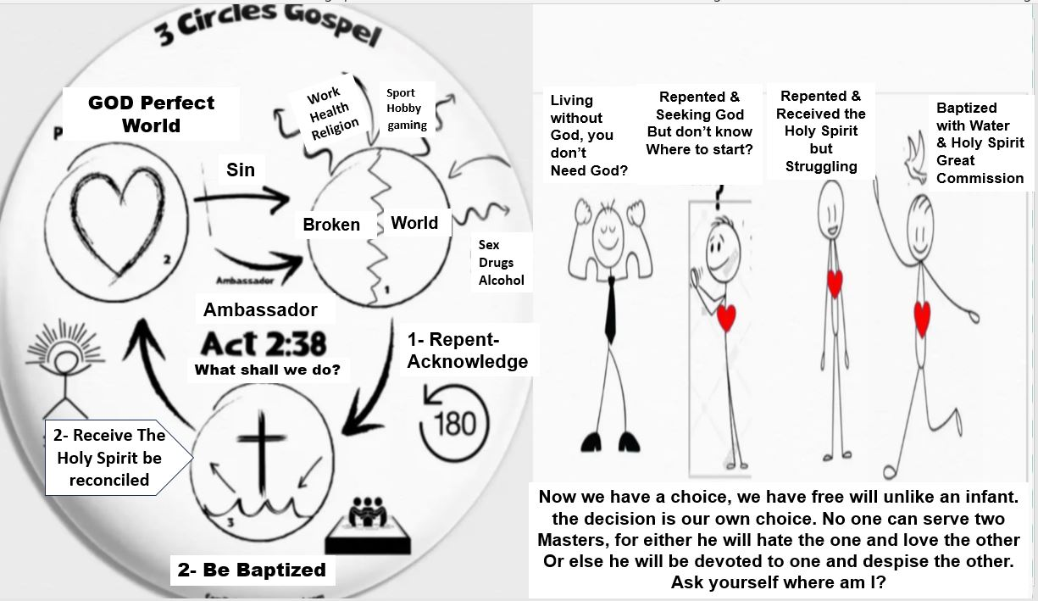
- You would agree with me that we live in a broken world, if you just look at the news, you’ll see the conflict of war between kingdom and kingdom territory and territory even in our home country you see the injustice
you see the violence you see racism, nation against nation, it’s really a kingdom of man mentality.
- But the reality of this is that this kingdom on this earth wasn’t always like this for, God who created all things He created this kingdom perfect in harmony, because He had full dominion as King over his Creation.
He made man to have dominion and to reign with Him as a delegate on this earth you see.
- But, man was deceived into thinking that he could do it his own way and through this horrible turning from God’s ways it brought separation from man and God and through his turning from God he introduced sin and death Upon all humanity,
What he did was he turned from God bringing sin and death and now we see the outcome of that through the brokenness of this system on this earth and now we’re living in this kingdom where it’s full of darkness and injustice.
- In the midst of this brokenness, we all long for this perfection and this purity, though, we don’t know what it is, we long for it in the midst of that we found
We try to find our own ways out to escape and through that
- We might go to education to receive more knowledge thinking we’ll find peace there
or our career through success and thinking we’ll find peace there
Or escape through relationship or any form of pleasure, with drugs or drinking whatever it is to make us feel good in this broken world
- But, the reality is that everything that we try to do in our own understanding and our own strength will always bring us back and snap us back into the brokenness of this world and this kingdom because we cannot do this through our own understanding it is broken, it is flawed.
Now though God is just and righteous, separating righteousness from
unrighteousness from the very beginning. God made a promise through His mercy and desire to be one with Hs creation He made a promise that he would restore this broken kingdom back to a kingdom of righteousness and purity, and that He would do this restoration through a man, and this man would come to remove the curse of sin and death and this man, is His son Jesus.
- Jesus came to remove the curse of sin and death by becoming a curse, tasting of death, His death which He freely gave though He died unrighteously it was the exact payment that destroyed the works of sin and death.
They buried him, and on the third day He rose from the dead. This is proof by God that this man would bring all things back into restoration into a restored state, when He rose again
He was crowned king, king over all, and now He sits on the right hand of the Father in power and authority.
- Waiting for that day when He’ll come to restore this broken world back to its perfect state and now that we’re waiting
for that day all those that are in this broken world, if they will turn from their own understanding and they’ll turn from their own ways,
to the ways of king Jesus, through repentance and baptism, swearing allegiance to Him their whole life
they will come into that place where sin and death is removed, so that they can live in harmony, even now!
- Until the return of king Jesus, while we wait for that beautiful day, we are commanded to go back into the broken world, as delegates now, as ambassadors of the coming kingdom, to proclaim the coming kingdom of God into this broken kingdom here
and snatch them out of the kingdom of darkness into the kingdom of the son, King Jesus
- We’ve been given that ministry and all those who come and swear allegiance to King Jesus, if they endure unto the end
they will be saved from that coming first purification into a restoration
to reign with King Jesus forevermore
This is the gospel of the kingdom

Most people I shared the gospel with never heard the whole the entirety from beginning to end.
They say I’ve never heard it that way, it’s really good, they like there is something to look forward to, it’s not just Jesus died on the cross. They say they said a prayer and didn’t see any change and so not getting into theology right now but this method
the entirety of the kingdom of God’s message has been very very fruitful and I really see that.
Jesus commanded His disciples, the apostles, and everyone in scripture proclaimed the coming kingdom of God and
they showed signs and wonders through healing casting demons out, raising the dead cleansing the leopard as a sign of the coming day when things will go
back into perfection the way that they were
I find this number one, very powerful and using this method
I find it very easy to find the division between those who want to hear and those who do not
So you don’t find yourselves talking to somebody too much with someone that’s not ready.
You can share what? in three, four minutes depending on how quick you can do it and you’ll quickly know who’s interested in hearing more and who’s not okay
so I think it’s really cool. The ones that are interested, you see if they have time to talk some more or can set up a time to meet with them again.
You guys can reach out to me on my website. I have plenty of tools that if you need to watch and learn from this teaching, there are videos available. There’s a whole system you can plug into.
Fix your eyes on Jesus, run this race and endure until the end, God bless you\

